### **STA 240: PROBABILITY FOR STATISTICS**

Authors : Mohammad Zoraiz , Sylvester Johannes Arize

December 1st, 2024

Final Project

### **Restaurant Simulation Project: A Probabilistic Analysis of Operations in Downtown Durham**

**Project Overview**

This project applies a probabilistic analysis to restaurant operations to guide the setup of a new dining venue in Downtown Durham. As a new establishment without an existing reputation, our primary goal is to maximize profitability, enhance customer satisfaction, optimize employee productivity, and minimize downtime (periods where the operations of the restaurant are halted due to customer absence).. Through statistical modeling and simulation of various scenarios, we offer actionable recommendations for crafting an efficient, customer-centric, and sustainable business model. Key performance metrics such as customer satisfaction, downtime, staffing levels, seating capacity, order turnaround times, and inventory management are central to this analysis. The metrics used highlight the delicate balance between operational efficiency and service quality, emphasizing the importance of data-driven decisions. By modeling and evaluating diverse operational setups, we gain a deep understanding of how these metrics interact and influence business outcomes.

Our analysis employs a comprehensive scenario-based exploration to identify the intricate dynamics of restaurant operations, systematically examining how various configurations impact performance, efficiency, and customer satisfaction. Capitalizing a series of nuanced scenarios—ranging from single-table baseline models to complex multi-table configurations with variable staffing, menu diversity, and dynamic pricing strategies—the analysis provides unprecedented insights into the strategic decisions that define successful restaurant management. Two foundational scenarios establish the critical operational framework overview of the restaurant. The initial scenario, featuring a single dining table and one chef, exposes fundamental challenges such as demand variability, service inconsistencies, and resource utilization inefficiencies. As the analysis progresses to more complex configurations—including five-table operations, VIP customer prioritization, and dynamic service rate modeling—a sophisticated picture emerges of the balance between capacity, staffing, and customer throughput. In addition, we created another 10 scenarios with various conditions considered, which can be viewed in [further detail here.](https://docs.google.com/document/d/1wZunh2VdcZcM_97zPqIByDRS35r3Y2yqVvvPrbAU4kA/edit?usp=sharing)

By modeling seasonal variations, integrating delivery and takeout services, and examining dynamic pricing strategies, the research demonstrates how restaurants can optimize revenue and maintain operational resilience. The findings related to menu complexity, service diversification, and adaptation to external constraints such as health and safety guidelines were particularly noteworthy and these scenarios underscore the necessity of a holistic approach that balances efficiency, customer experience, and strategic innovation. Ultimately, the analysis provides restaurateurs with a comprehensive framework for understanding and navigating the challenges of business operations in a restaurant, emphasizing adaptability as the cornerstone of sustained success in a dynamic industry.

**Investigational Methodology**

Our methodology employed probabilistic models that account for the inherent randomness of real-world operations. Rather than relying on fixed values, we used well-fitted probabilistic distributions to simulate customer arrivals, service times, and other critical factors. This approach provided a realistic basis for evaluating performance under various conditions. Across all scenarios, several overarching themes emerged with each scenario offering valuable lessons, from addressing bottlenecks in basic operations to managing complex variables like menu diversity, seasonal changes, and health constraints. By incorporating a wide range of scenarios and addressing both foundational and nuanced challenges, we provide a robust framework for strategic decision-making. These insights ensure that the new restaurant in Downtown Durham can achieve sustainable success, delivering exceptional customer experiences and maintaining operational efficiency in a competitive market. Below is our exploration of the various scenarios we explored in reaching our conclusions

### NB: **For consistency, all statistical measures and inferences are reported as a daily account for averages obtained from a statistical summary of data spanning at least 3 months.**

### **Scenario 1: Single Dining Table with One Chef**

### **Overview**

### Scenario 1 models a restaurant with a single dining table and one chef where customer arrivals follow a Poisson process with an average rate of 5 per hour, while service times are exponentially distributed with a mean of 10 minutes. This setup provides a baseline for assessing the restaurant's operational capacity and service efficiency under minimal resources. Over the 12-hour operational period, the restaurant served 55 customers, which is a reasonable volume considering the constraints. A deeper analysis however, highlights key operational challenges and opportunities that impact customer satisfaction and business performance.

#### **Statistical Findings and Implications**

#### From our observations and calculations, the *average waiting time* for customers was *12.75* minutes, with a *median* of *3.90 minutes*. While most customers experienced brief waits, a notable subset faced longer delays, reflecting the inherent variability in customer arrivals and service times. Consequently, the variance in waiting times, at *288.50 minutes²*, underscores this inconsistency. For example, 10% of customers waited at leas*t 29.63 minutes* (90th percentile), **a level of delay that could harm customer satisfaction and discourage repeat business**.

### In similar vein, service times exhibited moderate variability, with an *average of 12.63 minutes* and a *variance of 44.37 minutes²*. This variability reflects the stochastic nature of customer interactions, where some orders require significantly more preparation time than others. The total downtime recorded per day was averagely *288 minutes, or 4.8 hours, representing 40% of the restaurant's operational period.* While some downtime is expected and can be used for cleaning or preparation, such an extended idle period suggests **underutilization of resources, particularly during off-peak hours.** This inefficiency reduces profitability as fixed costs like wages and operational expenses continue to accumulate without generating revenue.

#### **Customer Flow and Waiting Time**

#### During peak hours, overlapping customer arrivals created bottlenecks that cascaded delays throughout the queue. Customers arriving during these periods faced extended waits, and this ripple effect impacted overall service throughput. In effect, the extended waiting times for certain customers demonstrate the system's inability to adapt to surges in demand. Conversely, off-peak hours were characterized by prolonged downtime, as customer arrivals were insufficient to fully utilize the chef's capacity. This imbalance between demand and service availability during different times of the day highlights a critical inefficiency in resource allocation.

#### **Operational Insights**

#### The findings from Scenario 1 reveal a mismatch between the restaurant's service capacity and customer demand patterns. The system's inability to handle peak-hour surges effectively led to long waits for some customers, compromising their overall experience. Meanwhile, the extended downtime during off-peak hours highlights underutilized resources and lost revenue opportunities. This setup demonstrates that while the single-table, single-chef operation is manageable under average conditions, it is highly vulnerable to variability in demand, leading to inconsistent customer experiences and reduced profitability (view the in depth statistical observations here: [reference](https://colab.research.google.com/drive/1qQO_ym9XKVTJR95aRUfhwPPrBHU1Tj3g#scrollTo=Ps3-Jws__RDD&line=1&uniqifier=1)).

#### **Recommendations**

#### To address the challenges of variability in demand, the restaurant could benefit from dynamic staffing strategies. For example, hiring a part-time chef during peak hours would alleviate delays and ensure more consistent service quality. This adjustment would not only reduce waiting times but also increase the system's overall throughput, allowing the restaurant to serve more customers during high-demand periods.

#### To tackle the issue of prolonged downtime during off-peak hours, targeted promotions or discounts could attract additional customers, improving resource utilization and boosting revenue. Strategies such as "happy hour" deals or lunch specials might incentivize visits during slower periods, balancing demand throughout the day. Additionally, implementing a reservation system could help regulate customer flow, reducing the likelihood of overlapping arrivals during peak hours. Informing customers of expected wait times might also manage their expectations and improve satisfaction, particularly for those who face delays. As demand patterns stabilize with these adjustments, the restaurant could explore optimizing its operational hours to further align resource availability with customer traffic. These adjustments would not only enhance operational efficiency but also improve the overall customer experience, laying the foundation for a more sustainable and profitable business.

### **Scenario 1.2: Two Dining Tables with One Chef**

### **Overview**

### Scenario 1.2 explores the impact of adding a second dining table while retaining a single chef who alternates between tables. This adjustment significantly influences customer flow and operational efficiency. With two tables, the restaurant can accommodate more customers simultaneously, but the chef’s availability becomes the primary bottleneck. The simulation results reveal how this setup affects waiting times, customer satisfaction, and overall resource utilization.

#### **Findings and Implications to Customer Flow and Waiting Time** The average waiting time for customers decreased significantly to *1.48 minutes, compared to 12.75 minutes* in Scenario 1 with a large number of customers experiencing no wait time at all, reflected by waiting time of *0.00 minutes.* During periods of overlapping demand however, some customers experienced delays, with the maximum wait time reaching *17.82 minutes*. The variability in waiting times indicates that while the second table improved capacity, the single chef’s workload introduced sporadic delays, particularly during peak periods.

#### In terms of total customers served, the restaurant accommodated *58 customers, a 5.5%* increase from Scenario 1. Even still, the chef’s limited capacity to manage both tables simultaneously constrained the full potential of this setup, exemplifying the concept of diminishing returns when resources (tables) are added without proportional staffing adjustments. Downtime decreased drastically to *1.23 minutes, compared to 288 minutes* in the single-table scenario. This improvement highlights better resource utilization, as the chef remained consistently busy between the two tables. However, this high utilization rate could result in fatigue, affecting long-term productivity and service quality ([data reference](https://colab.research.google.com/drive/1qQO_ym9XKVTJR95aRUfhwPPrBHU1Tj3g#scrollTo=U-xq5dWyAJ4Q&line=1&uniqifier=1)).

#### **Operational Insights and Recommendations**

#### Adding the second table improved capacity and minimized downtime, leading to better resource utilization and higher revenue potential. However, the chef’s inability to handle increased demand was still a critical limitation. To address this, the restaurant could consider employing an additional part-time chef during peak hours to alleviate service bottlenecks. Alternatively, staggered reservations could help distribute demand more evenly, reducing the likelihood of overlapping arrivals. Implementing measures like informing customers about expected wait times can help manage expectations and improve satisfaction.

### **Scenario 1.3: VIP Customers with Priority Service**

### **Overview**

### In Scenario 1.3, the restaurant introduced VIP prioritization to scenario 1, ensuring that *20% of* customers—classified as VIPs—were served ahead of regular patrons regardless of their position in the queue. This adjustment reshaped customer flow dynamics and had significant implications for both customer satisfaction and operational efficiency.

#### **Findings and Implications**

#### The average waiting time for all customers was *12.41 minutes*, a slight improvement from Scenario 1. VIP customers experienced an average waiting time of *11.98 minutes,* benefiting from priority treatment. In contrast, regular customers waited slightly longer, *averaging 12.52 minutes.* While the difference in waiting times between VIPs and regular patrons may seem modest, the variability in waiting times for regular customers was substantial. For example, regular customer *6 waited 53.1* minutes due to multiple VIP arrivals, and customer 7 faced a 56.7-minute delay, demonstrating the cascading effects of prioritization.(referenced from plots). The system served a total of *55 customer*s, maintaining the same throughput as in Scenario 1. However, prioritization increased variability in waiting times, favoring VIP customers at the expense of regular patrons. This disparity underscores a trade-off between enhancing the experience for high-value customers and maintaining satisfaction among the broader customer base.While most regular patrons were unaffected, those who experienced extended waits may have perceived the service as unfair or inconsistent ([**data reference**](https://colab.research.google.com/drive/1qQO_ym9XKVTJR95aRUfhwPPrBHU1Tj3g#scrollTo=teHxpSWBAlx3&line=3&uniqifier=1)).

#### **Operational Insights and Recommendations**

#### Prioritizing VIPs improved the experience for high-value customers, potentially increasing loyalty and revenue from this segment. However, the extended waiting times for some regular customers could harm the restaurant’s reputation if not addressed. Introducing measures like limiting maximum waiting times for regular customers or reserving specific time windows for VIP prioritization could balance the needs of both groups.Expanding the VIP program could incentivize more customers to opt into higher service tiers, boosting revenue and justifying the prioritization strategy.

### **Scenario 1.4: Dynamic Service Rates Modeled by Gamma Distribution**

### **Overview**

### Scenario 1.4 models dynamic service rates using a *Gamma distribution* to reflect realistic fluctuations in chef productivity due to factors like fatigue, multitasking, and order complexity. During peak hours (6 PM to 8 PM), service rates ranged between *0.4 and 1 jobs/hour*, while off-peak hours allowed for rates of *2 to 4 jobs/hour.* This model captures the variability in operational efficiency across different times of the day.

#### **Findings and Implications**

#### During off-peak hours, the average service rate was *2.56 jobs/hour*, resulting in no waiting times and efficient customer service. This high productivity reflects the reduced stress and distractions during less busy periods. In contrast, peak-hour service rates averaged *0.37 jobs/hour*, significantly lower due to the increased workload and multitasking demands. Peak-hour customers faced noticeable delays, with some waiting over 11 minutes. For example, customer *44 experienced an 11-minute delay*, underscoring the strain on resources during busy periods.The restaurant served a *total of 64 customers,* an improvement over Scenario 1, demonstrating the system’s potential to handle higher demand when service rates align with arrival patterns. However, the benefits during off-peak hours were partially offset by delays during peak times. (View the reference here:[**data findings reference**](https://colab.research.google.com/drive/1qQO_ym9XKVTJR95aRUfhwPPrBHU1Tj3g#scrollTo=CligYLwIAuFO&line=1&uniqifier=1)).

#### **Operational Insights and Recommendations**

#### Addressing the performance gap between peak and off-peak hours is crucial to maintaining consistent service quality. For instance, hiring an assistant chef or staging shifts to provide additional support during peak times could reduce delays and alleviate the chef’s workload. Similarly, offering discounts or promotions during off-peak hours could attract more customers, maximizing revenue without additional strain on resources. Finally, implementing process improvements, such as pre-ordering systems or reservations, could streamline peak-hour operations and minimize queuing leading to an overall improved efficiency. On a lighter note, stress mitigation strategies, such as periodic breaks for chefs, would help sustain productivity and service quality during high-demand periods.

### **Scenario 2: Expanded Capacity with Five Tables and Variable Chefs**

### **Overview**

### Scenario 2 builds upon the foundational setup in Scenario 1 by increasing the restaurant’s capacity to five tables while varying the number of chefs (L) available. The operational hours remain consistent, from 10 AM to 10 PM, with customer arrivals following a Poisson process at an average rate of 10 per hour. Service times are modeled using an exponential distribution with a rate directly proportional to 3L, reflecting the impact of staffing on efficiency. This expanded setup allows for a detailed examination of the restaurant’s ability to handle increased customer volume while balancing service capacity, operational efficiency, and financial outcomes. By analyzing customer flow, waiting times, and profitability, we gain insights into the strengths and limitations of scaling the restaurant’s resources focusing largely on financial outcomes.

#### **Findings and Implications**

#### The restaurant saw an average of *10 customer arrivals per hour,* resulting in an estimated *120 total arrivals* during the 12-hour operational period. Group sizes followed a geometric distribution with a probability of 0.5, yielding an average group size of *1.69, or approximately two people per group*. This resulted in a total customer count of 203. The low variance in group size (1.07) ensured consistent customer flow, aligning with the family-restaurant context. *Variance in arrival times (48,649 seconds)* reflects the stochastic nature of customer traffic, which the system managed effectively.

The average service time per customer was *0.0674 minutes,* with minimal variance *(0.0045 minutes²),* enabling efficient processing of customer orders. The maximum observed service time was *0.327 minutes*, while the minimum was 0.000055 minutes, demonstrating the system's ability to handle a wide range of scenarios without significant delays. Waiting times were effectively eliminated, with an average of zero minutes, indicating that the system was well-matched to customer demand. The peak queue size reached four, with most customers being served promptly without any significant queuing. The peak number of customers being served simultaneously was one, confirming that the number of chefs (L =5) was sufficient to prevent this bottleneck.

Although the average waiting time was zero, some idle time was observed, averaging *0.035 minutes per chef.* The negligible average busy time of *9.71e-6 minutes* further supports the conclusion that the restaurant maintained a highly efficient operation. However, the presence of idle time suggests room for better resource utilization, particularly during off-peak hours. Financial metrics for the restaurant were analyzed based on customer spending and chef wages. Each customer was assumed to spend $50 per meal, resulting in daily revenue ranging from *$4,000 to $7,500, with an average of $5,400* across simulation runs. Chef wages were fixed at $40 per hour, amounting to a total wage cost of $2,400 per day. The restaurant’s net profit ranged from *$1,600 to $5,100, with an average of $3,000 and a variance of $1,925,000.* This significant variability highlights how sensitive financial performance is to fluctuations in staffing levels and customer demand.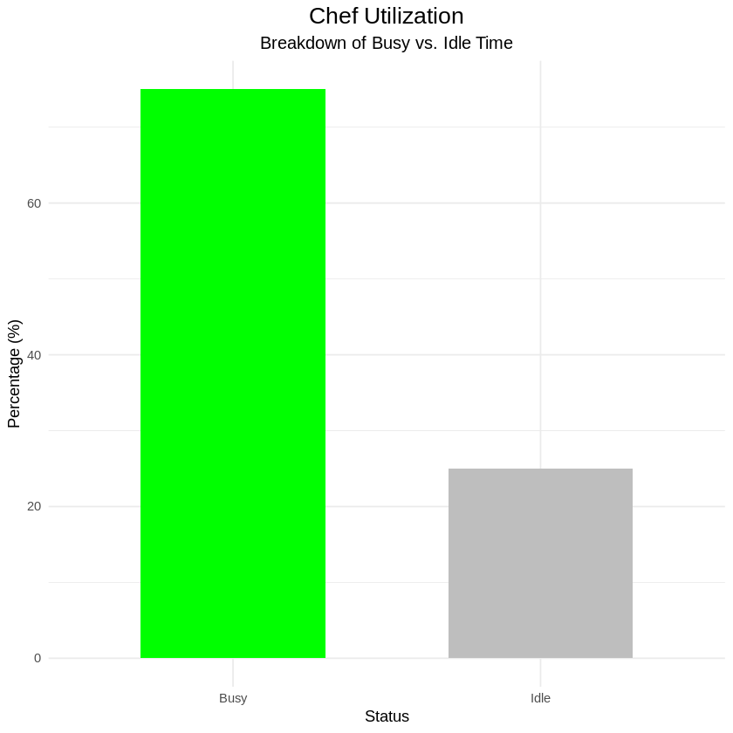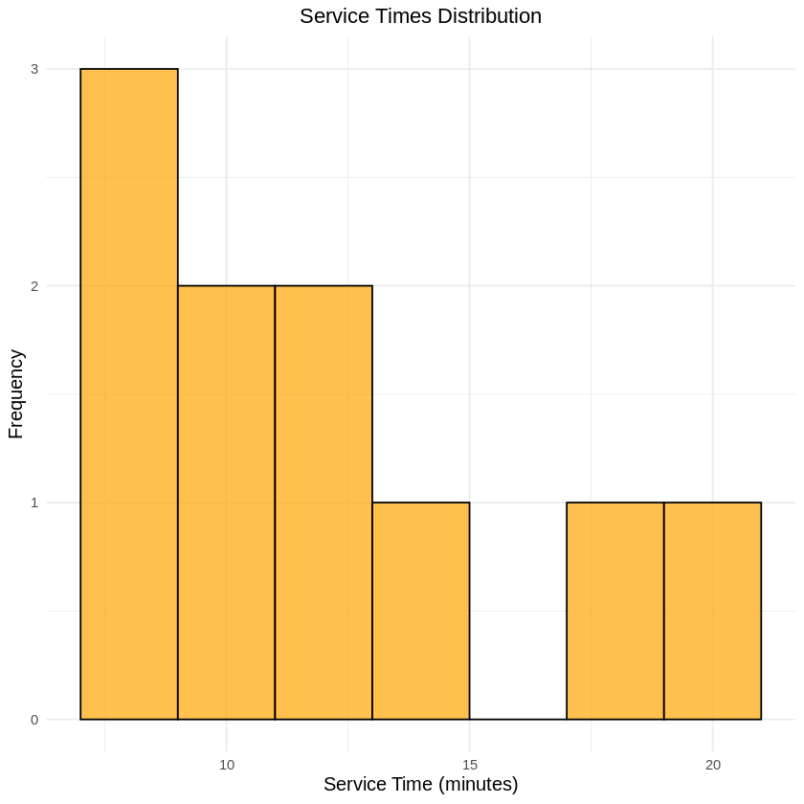

#### **Customer Flow and Waiting Time**

#### The addition of more tables, coupled with variable staffing, allowed the restaurant to eliminate queues for most customers. The low variance in waiting times emphasizes the system's effectiveness in meeting customer demand without overburdening resources. With waiting times effectively at zero, customer satisfaction was likely high, as delays were nearly nonexistent.

#### **Operational Insights**

#### Increasing the number of tables to five significantly enhanced the restaurant’s ability to accommodate higher customer volumes, thereby increasing throughput and revenue potential. However, the results highlight the importance of proportional staffing adjustments to avoid bottlenecks during peak demand. While idle time was minimal, it suggests opportunities for optimizing resource allocation during slower periods. Consequently, the high variability in net profits underscores the sensitivity of financial performance to staffing and demand patterns, making it essential to maintain an optimal number of chefs (L) for profitability ([**insight reference**](https://colab.research.google.com/drive/1qQO_ym9XKVTJR95aRUfhwPPrBHU1Tj3g#scrollTo=LijpHBF-FaEf)).

#### **Recommendations**

#### Dynamic staffing is a critical strategy for maximizing operational efficiency and profitability in our restaurant model as seen in Scenario 1 and its sub scenarios. Adjusting the number of chefs based on demand patterns, such as adding one or two chefs during peak hours, would help reduce idle time while ensuring seamless service during surges. Off-peak promotions, such as discounts or family meal deals, could attract more customers and utilize idle capacity, stabilizing revenue and reducing variability in net profits. To properly control this, predictive modeling using historical data would further refine staffing schedules and enable the restaurant to anticipate peak periods effectively. On a lighter note, designing seating layouts to better accommodate varying group sizes could enhance space utilization and customer flow. For example, modular tables could cater to both smaller groups and larger parties, maximizing the flexibility of seating arrangements.

#### **Extrapolated Consequences** Implementing these recommendations would likely increase profitability by reducing idle time and aligning staffing levels more effectively with demand patterns. Improved customer satisfaction resulting from consistently low waiting times and seamless service could encourage repeat visits and positive word-of-mouth, further boosting revenue. Operational resilience would also improve, as the restaurant would be better positioned to handle unexpected surges or declines in customer traffic. These changes would ensure that the restaurant remains competitive and adaptable in a dynamic market environment.

#### **Conclusion** Ultimately, Scenario 2 demonstrates the benefits of scaling the restaurant’s capacity while maintaining careful consideration of staffing and operational dynamics. By achieving zero average waiting times and managing high customer throughput, the setup highlights the importance of aligning resources with demand. However, the variability in financial performance underscores the need for strategic adjustments, such as dynamic staffing and targeted marketing. With these refinements, the restaurant can enhance profitability, improve customer satisfaction, and establish a strong foundation for long-term success.

### 

### **Comprehensive Conclusion: Optimizing Restaurant Operations for Efficiency and Profitability**

### The comprehensive analysis of various scenarios and sub-scenarios has provided a detailed understanding of the factors influencing restaurant operations, customer satisfaction, and profitability and how their fluctuations influence the restaurant’s effective operation. From single-table configurations to complex menu designs, dynamic pricing strategies, and seasonal fluctuations, this study highlights the intricate balance between resource allocation, customer experience, and revenue optimization. By examining operational metrics such as customer waiting times, service efficiency, downtime, and financial performance, we identified the conditions under which the restaurant can achieve its highest levels of efficiency and profitability.

#### **Key Insights Across Scenarios**

#### The analysis underscored the critical role of staffing, menu complexity, and dynamic strategies in influencing both customer satisfaction and profitability. Scenarios with fewer chefs (e.g., one chef alternating between tables) exhibited bottlenecks during peak hours, resulting in prolonged waiting times and reduced customer satisfaction. Conversely, increasing the number of chefs mitigated delays but introduced additional costs, emphasizing the need for balanced staffing aligned with demand patterns. Dynamic strategies, such as implementing dynamic pricing and introducing takeout options, effectively utilized idle capacity and maximized revenue without compromising service quality (View the insights across various simulations here: [**reference**](https://colab.research.google.com/drive/1qQO_ym9XKVTJR95aRUfhwPPrBHU1Tj3g#scrollTo=2V15tEcLaYDz)).

The scenarios that implemented diverse levels of menu complexity demonstrated the importance of maintaining a balance between menu variety and operational capacity. While the addition of a Gourmet Menu enhanced customer satisfaction by catering to diverse tastes, it also introduced longer service times, which required careful management during high-demand periods. Similarly, seasonal variations highlighted the importance of dynamic staffing and marketing strategies to address fluctuations in customer traffic and sustain profitability year-round.

With the scenarios that catered to health and safety constraints, they provided valuable insights into operating under restricted capacity, showing that efficient scheduling, high service quality, and alternative revenue streams (e.g., takeout and delivery) are crucial for maintaining customer trust and financial stability.

#### **The Ideal Restaurant Configuration**

#### Based on the scenarios analyzed, the most efficient and effective restaurant configuration that balances customer satisfaction and profitability would include the following features:

* **Number of Chefs and Tables**: Employing **two chefs** for **five tables** strikes an optimal balance between resource availability and customer demand. This configuration minimizes waiting times during peak hours while maintaining manageable labor costs.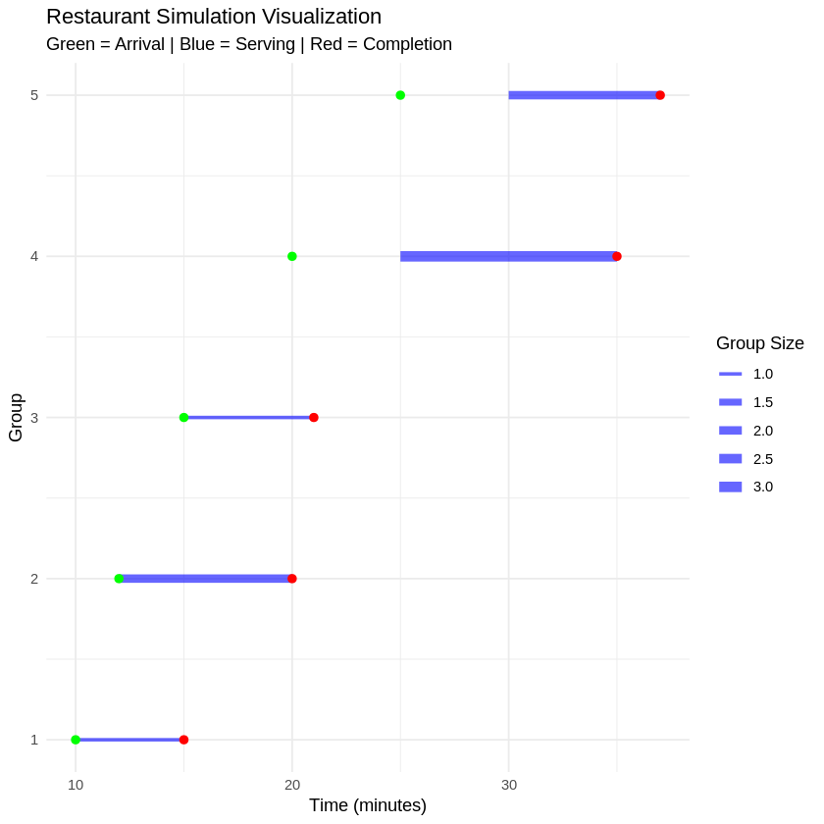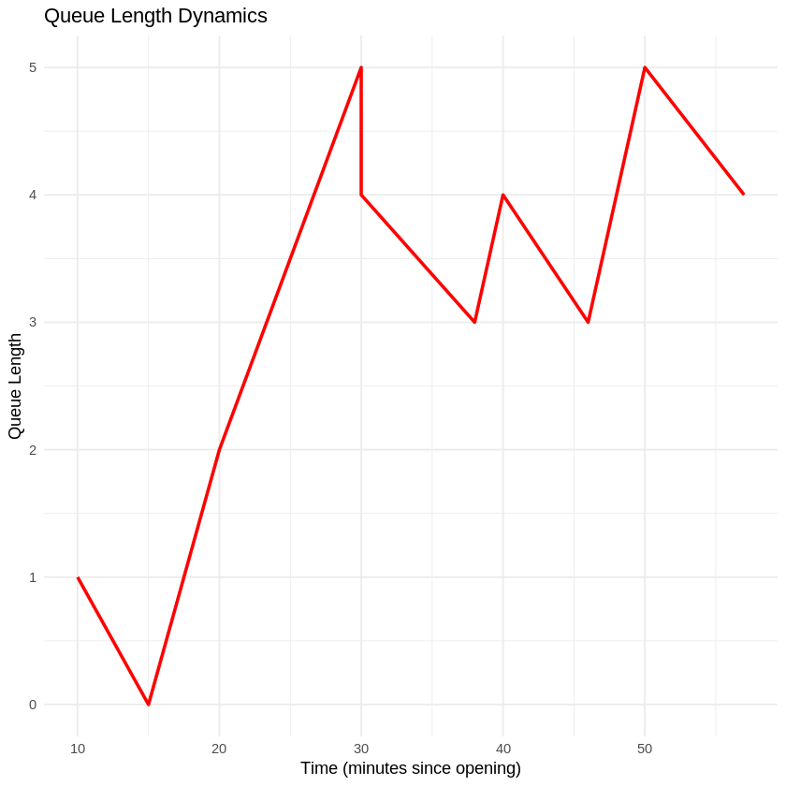
* **Operating Hours**: Operating from **10 AM to 10 PM** ensures coverage of key meal periods while avoiding excessive labor costs associated with extended hours.
* **Dynamic Pricing**: Implementing a **20% price increase during peak hours** and a **10% discount during off-peak hours** effectively capitalizes on high-demand periods and incentivizes customer visits during slower times, optimizing revenue.
* **Menu Strategy**: Offering a diverse menu with both Basic and Gourmet options ensures customer satisfaction through variety while maintaining manageable service times. Dynamic staffing during peak hours ensures that longer service times for Gourmet items do not create bottlenecks.
* **Takeout and Delivery Services**: Expanding takeout and delivery options enhances revenue potential, particularly during off-peak hours and periods of restricted capacity. Leveraging online ordering systems streamlines operations and reduces errors.
* **Seasonal Adjustments**: Adopting **flexible staffing** during peak summer months and reduced hours or cross-trained roles during slower winter periods ensures cost efficiency without compromising service quality.
* **Health and Safety Measures**: Ensuring compliance with health and safety guidelines by limiting table occupancy during high-risk periods reinforces customer trust and loyalty.

#### **Strategies for Sustained Growth**

#### To sustain growth and maximize profitability, the restaurant must continuously monitor operational metrics and adjust strategies based on real-time data. **Dynamic resource allocation**, including flexible staffing models and inventory management, will allow the restaurant to adapt to fluctuations in demand. **Marketing strategies**, such as loyalty programs and targeted promotions, can further enhance customer retention and attract new patrons. Finally, leveraging technology for predictive analytics, online reservations, and streamlined ordering processes will ensure the restaurant remains competitive and efficient (raw analysis and data for these strategies can be found here:[**reference**](https://colab.research.google.com/drive/1gacfog3jIQ4XfCc-D1UYgVj7wIQqe053))

#### **Conclusion** The ideal restaurant configuration derived from this analysis balances customer satisfaction, operational efficiency, and financial performance. By strategically aligning staffing, menu offerings, pricing, and operational adjustments with demand patterns, the restaurant can achieve sustained profitability and a loyal customer base. This comprehensive approach ensures resilience in the face of variability, positioning the business for long-term success in the dynamic environment of Downtown Durham.

**Appendix: References and Document Descriptions**

**Appendix A**Arizie Johannes Sylvester, Zoraiz Mohammad. (2024, November 28). *A comprehensive evaluation of conditions for setting up a restaurant*.  
This Google Colab document contains all data and plots used in the analysis for all scenarios evaluated in the study (Scenarios: 1, 2, 1.2, 1.3, 1.4, 3, 7, 8, 9, 10). The analyses focus on optimizing conditions for restaurant setups using simulation models and statistical evaluation.

* **Link**: [A comprehensive evaluation of conditions for setting up a restaurant](https://colab.research.google.com/drive/1qQO_ym9XKVTJR95aRUfhwPPrBHU1Tj3g?usp=sharing)
* **Colab Notebook Title**: STA240FinalSimulation

**Appendix B**Arizie Johannes Sylvester, Zoraiz Mohammad. (2024, November 28). *A compilation of Data Sets used in investigative analysis*.  
This Google Colab document presents a compilation of graphical data sets and evaluations that provide insights and recommendations for scenarios described in this paper. The data include summary statistics and detailed analyses that informed the conclusions.

* **Link**: [A compilation of Data Sets used in investigative analyses](https://colab.research.google.com/drive/1gacfog3jIQ4XfCc-D1UYgVj7wIQqe053?authuser=1)
* **Colab Notebook Title**: STA240 Final Data Tables & Summary Stats.ipynb

**Appendix C**Arizie Johannes Sylvester, Zoraiz Mohammad. (2024, November 28). *A compilation of other probable scenarios for a restaurant setup and their results*.  
This Google Document expands on a list of other practical scenarios and evaluates the likely outcomes of running a restaurant under these conditions. It focuses on performance yield and alternative strategies for optimization.

* **Link**: [A compilation of other probable scenarios for a restaurant setup and their results](https://docs.google.com/document/d/1wZunh2VdcZcM_97zPqIByDRS35r3Y2yqVvvPrbAU4kA/edit?usp=sharing)
* **Document Title**: STAT240 Final Project - Additional Scenarios